1970
Zn → Zn²⁺ + 2 e- E° = 0.76 v
Cu → Cu²⁺ + 2 e- E° = -0.34 v
The solubility of H₂S in water is approximately 0.1-molar.
Zn(OH)₂(s) + 2 OH⁻ → Zn(OH)₄²⁻ K = 4.5×10⁻²
Cu(OH)₂(s) + 2 OH⁻ → Cu(OH)₄²⁻ K = 1.6×10⁻³
K_{sp} of ZnS = 10⁻²³, K_{sp} of CuS = 10⁻⁴⁴
A solution is approximately 1 molar in Cu²⁺ and 1 molar in Zn²⁺. Based on the data above, outline three different methods for separating them discussing the theoretical bases for these separations.
Answer:
(1) Add a dilute solution of H₂S, or any other soluble sulfide, dropwise to the solution to precipitate the less soluble CuS. Do not exceed a concentration of about 10⁻²³ M or ZnS will precipitate.
(2) Copper(II) ions are more easily reduced than Zn²⁺ (it has a lower E° than the zinc ion). Therefore, placing some iron (E° = 0.44 v) in the solution will cause the Cu²⁺ to reduce, the Fe to oxidize (to Fe²⁺), but the Zn²⁺ will not reduce.
(3) Precipitate the two with 4 moles of OH⁻, add a slight excess of hydroxide and the more soluble, Zn(OH)₄²⁻, will dissolve.

1972
A 10.00 milliliter sample of NH₃ solution is titrated with a standard HCl solution.
1) An unknown volume of water is added to the HCl solution.
2) An unknown volume of water is added to the 10.00 milliliter sample of NH₃ solution.
3) Phenolphthalein is used as the indicator.
For each of these three steps taken during the titration:
(a) State whether it introduces an error into the titration results.
(b) For any of the steps that introduce(s) an error, state whether the titration result will be raised or lowered compared to the result obtained if the error had not been made.
(c) Explain why the result is high or low for each error that you detect.
Answer:
(a) (1) error (2) no error (3) error
(b) (1) raised (3) lowered
(c) (1) a more dilute solution of HCl will require a greater volume of titrant. Therefore the apparent concentration of ammonia is stronger than the real concentration.
(3) The titration of a weak base by a strong acid has an equivalence point in the weak acid range while phenolphthalein changes color in the weak base range. Therefore, less acid would be added to see this change than is required and the apparent concentraion of ammonia would be less than the real concentration.

1973 D
Briefly describe four different laboratory tests by which NaNO₃ can be distinguished from NH₄Cl.
Answer:
(1) Warm both solids, ammonium chloride can be identified by the smell of ammonia.
(2) Dissolve equal amounts in water, the ammonium chloride solution is slightly acidic while the sodium nitrate is neutral.
(3) Dissolve each in water, add a few drops of copper (II) nitrate to each. The bluer solution is the ammonium chloride.
(4) Dissolve each in water, add a solution of Pb²⁺, the one that gives the white precipitate of PbCl₂ is ammonium chloride.
[many other tests possible]

1973 D
What minimum data are needed to determine the molecular weight of each of the following substances in the laboratory? In each case, use a different method and give the mathematical formula(s) to be used for calculating the molecular weight from these minimal data.
(a) A liquid that is insoluble in water and that boils at 65°C
(b) A solid nonelectrolyte
Answer:
(a) Vaporize a sample of the liquid at a specific temperature, T, in a specific volume container, V, under a specific pressure, P. Condense the vapor and determine its mass, M. Using the universal gas law, PV= nRT, calculate n. The molecular weight = M/n.
(b) Measure a known mass of a solvent, M_{solvent}. Look-up its freezing point depression constant, kf. Measure a known mass of solid non-electrolyte, Msolute and mix into the solvent. Measure the change in the freezing point between the solution and the pure solvent, ΔT_{fp}. Calculate the moles of solute per kg of solvent = (ΔT_{fp}/kf). Calculate the grams solute/kg solvent = Msolute/M_{solvent} (in kg). The molecular weight is this mass/moles.

1974 D
The heat liberated when 1.00 mole of acetic acid, HC₂H₃O₂, reacts with 1.00 mole of sodium hydroxide, NaOH, is 12.7 kilocalories. Describe how this value can be determined in a general chemistry laboratory.
Answer:
Use of calorimeter
Quantification of reactants
Measurement of temperature increase
Quantification of total vol. (mass of solution)
Calculation described (inc. heat liberated per mole)

1975 D
Briefly outline a laboratory procedure that can be used to determine the composition of an alloy of copper and silver. The alloy dissolves completely in concentrated nitric acid.
Answer:
One of many possible correct solutions:
Mass a sample of the alloy. Dissolve alloy in concentrated nitric acid. Precipitate the Ag⁺ ions with any chloride (HCl as an example) as AgCl, the Cu²⁺ remains in solution. Filter the precipitate, wash, dry, and weigh. The silver is 75.26% of the mass of the precipitate.

1979 D
In a laboratory determination of the atomic weight of tin, a sample of tin is weighed in a crucible. Nitric acid is added, and the reaction proceeds to give a hydrated tin(IV) oxide plus NO₂ and H₂O. The hydrated tin(IV) oxide is then heated strongly and reacts as follows:
SnO₂.xH₂O(s) → SnO₂(s) + xH₂O(g)
The SnO₂ is finally cooled and weighed in the crucible. Explain the effect on the calculated atomic weight of tin that would result from each of the following experimental errors:
(a) Considerable spattering occurs when the nitric acid is added to the tin.
(b) The hydrated tin(IV) oxide is not heated sufficiently to change it completely to tin oxide.
Answer:
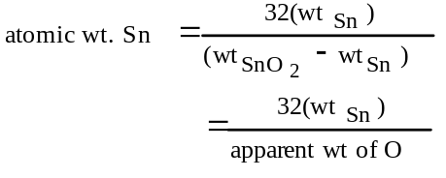
(a) mass of residue will be too low, ∴ the apparent at. wt. will be too high.
(b) mass of residue will be too high, ∴ the apparent at. wt. will be too low.

1982 D
Describe a laboratory procedure needed to carry out each of the following.
(a) Separate a mixture of powdered solid CaCl₂ and CaCO₃.
(b) Determine the concentration of solute in an aqueous sodium chloride solution and give the concentration units that your method provides.
(c) Separate a mixture of two volatile liquids.
Answer:
(a) Add water to the mixture. CaCO₃ doesn’t dissolve, whereas, the CaCl₂ does dissolve. Filter the solution. The aqueous CaCl₂ solution passes through the filter paper and the CaCO₃ is collected on the paper.
(b) Pipet an aliquot of known volume into a flask. Add excess AgNO₃ solution to precipitate AgCl. Filter, dry, and then weigh the AgCl.
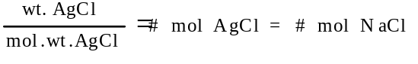
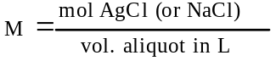
OR
Take a known volume of solution. Evaporate solution to dryness and weigh the NaCl residue.
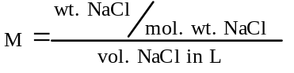
[other procedures possible, such as the use of colligative properties, etc.]
(c) Fractional distillation.

1984 C
Given solid samples of KI and of (NH₄)₂CO₃, briefly describe four simple laboratory tests by which these two compounds can be distinguished. For each test, report the expected result for each compound.
Answer:
Possibilities include:
(1) Flame test: K⁺ lavender; (NH₄)₂CO₃, no lavender
(2) Add Cl₂ and CH₂Cl₂: KI, pink color in organic layer; (NH₄)₂CO₃, no change
(3) Add Pb²⁺: KI, yellow ppt of PbI₂; (NH₄)₂CO₃, white ppt of PbCO₃.
(4) Add Ag⁺: KI, pale yellow ppt of AgI; (NH₄)₂CO₃, white ppt of Ag₂CO₃.
(5) Add I₂: KI, brown color of I₃⁻; (NH₄)₂CO₃, no change
(6) Add good oxidizing agent: KI, brown color of I₃⁻; (NH₄)₂CO₃, no change
(7) Add strong base: KI, no change; (NH₄)₂CO₃, odor of NH₃ or color change of red litmus
(8) Add Ba²⁺, or Ca²⁺ or Mg²⁺: KI, no change; (NH₄)₂CO₃, with precipitate of carbonate
(9) Dissolve in water and use litmus: KI, neutral; (NH₄)₂CO₃, basic
(10) Add nonoxidizing acid: KI, no change; (NH₄)₂CO₃, bubbles of CO₂
(11) Test melting points: KI, high; (NH₄)₂CO₃, decomposes before melting

1985 D
Describe a separate laboratory procedure for preparing each of the following.
(a) Pure barium sulfate from an aqueous solution of barium chloride.
(b) A pure aqueous solution of copper(II) nitrate from solid copper(II) carbonate.
(c) A pure aqueous solution of calcium chloride from an aqueous solution of calcium bromide.
Answer:
(a) Precipitation of insoluble BaSO₄ by adding a solution of a soluble sulfate, e.g., Na₂SO₄. Isolate BaSO₄ by filtration. Purify BaSO₄ by washing and drying it.
(b) Dissolve CuCO₃ with HNO₃ to form Cu(NO₃)₂ solution. Isolate by avoiding the addition of excess acid. Purify by heating to drive off CO₂.
(c) Form CaCl₂ solution by treating CaBr₂ solution with Cl₂. OR Add a soluble carbonate. Separate the precipitated CaCO₃, wash, and dissolve in HCl. Purify CaCl₂ solution by extracting the Br₂ with CH₂Cl₂ or equivalent. OR Heat the solution.

1988 D
An experiment is to be performed to determine the standard molar enthalpy of neutralization of a strong acid by a strong base. Standard school laboratory equipment and a supply of standardized 1.00-molar HCl and standardized 1.00-molar NaOH are available.
(a) What equipment would be needed?
(b) What measurements should be taken?
(c) Without performing calculations, describe how the resulting data should be used to obtain the standard molar enthalpy of neutralization.
(d) When a class of students performed this experiment, the average of the results was -55.0 kilojoules per mole. The accepted value for the standard molar enthalpy of neutralization of a strong acid by a strong base -57.7 kilojoules per mole. Propose two likely sources of experimental error that could account for the result obtained by the class.
Answer:
(a) Equipment needed includes a thermometer, and a container for the reaction, preferably a container that serves as a calorimeter, and volumetric glassware (graduated cylinder, pipet, etc.).
(b) Measurements include the difference in temperatures between just before the start of the reaction and the completion of the reaction, and amounts (volumes, moles) of the acid and the base.
(c) Determination of heat (evolved or absorbed): The sum of the volumes (or masses) of the two solutions, the change in temperature and the specific heat of water are multiplied together to determine the heat of solution for the sample used. (q = m.c_{p}.ΔT). Division of the calculated heat of neutralization by moles of water produced, or moles of H⁺, or moles of OH⁻, or moles of limiting reagent.
(d) Experimental errors: heat loss to the calorimeter wall, to air, to the thermometer; incomplete transfer of acid or base from graduated cylinder; spattering of some of the acid or base so that incomplete mixing occurred…
Experimenter error: dirty glassware, spilled solution, misread volume or temperature…

1990 D
An experiment is performed to determine the empirical formula of a copper iodide formed by direct combination of elements. A clean strip of copper metal is weighed accurately. It is suspended in a test tube containing iodine vapor generated by heating solid iodine. A white compound forms on the strip of copper, coating it uniformly. The strip with the adhering compound is weighed. Finally, the compound is washed completely from the surface of the metal and the clean strip is dried and reweighed.
DATA TABLE
Mass of clean copper strip 1.2789 grams
Mass of copper strip and compound 1.2874 grams
Mass of copper strip after washing 1.2748 grams
(a) State how you would use the data above to determine each of the following. (Calculations not required.)
(1) The number of moles of iodine that reacted
(2) The number of moles of copper that reacted
(b) Explain how you would determine the empirical formula for the copper iodide.
(c) Explain how each of the following would affect the empirical formula that could be calculated.
(1) Some unreacted iodine condensed on the strip.
(2) A small amount of the white compound flaked off before weighing.
Answer:
(a) (1) (mass of Cu Strip + compound) - (mass of original clean Cu strip) = mass of iodine
(mass of iodine)/(atomic mass of iodine) = moles of iodine in the sample of compound
(2) (mass of original clean Cu strip) - (mass of strip after washing and drying) = mass of Cu
(mass of Cu) / (atomic mass of Cu) = moles of Cu in sample of compound
(b) The empirical formula is the ratio (moles iodine) / (moles Cu). OR (moles Cu) / (moles iodine).
(c) (1) Unreacted I₂ would make the apparent mass of compound and the iodine too high. Thus, the I:Cu ratio in the empirical formula would be too high.
(2) If some compound flaked off, the mass of compound (and the I₂) would be too low. Thus the I:Cu ratio in the empirical formula would be too low.

1991 D
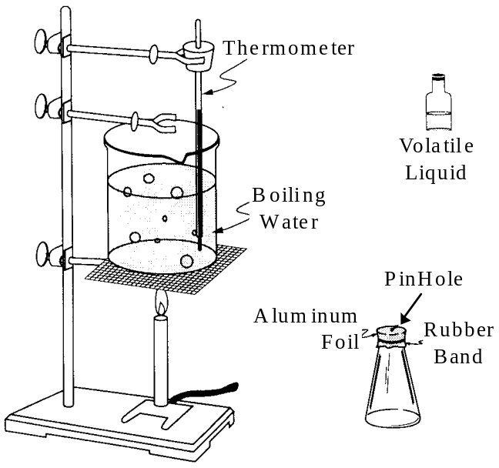
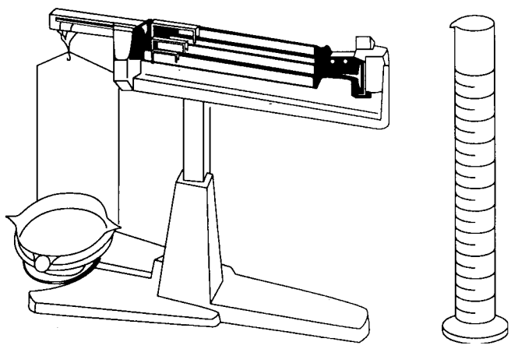
An experiment is to be performed to determine the molecular mass of a volatile liquid by the vapor density method. The equipment shown above is to be used for the experiment. A barometer is also available.
(a) What data are needed to calculate the molecular mass of the liquid?
(b) What procedures are needed to obtain these data?
(c) List the calculations necessary to determine the molecular mass.
(d) If the volatile liquid contains non-volatile impurities, how would the calculated value of the molecular mass be affected? Explain your reasoning.
Answer:
(a) 1. mass of flask + cap (foil)
2. mass of flask + cap + liquid
3. temp. of boiling water
4. barometric pressure
5. volume of flask
(b) 1. Measure mass of empty flask w/cap
2. Pour about 3 mL of volatile liquid into flask.
3. Replace cap and place flask into boiling water.
4. Record temperature and barometric pressure.
5. When all the liquid has evaporated remove flask and allow to cool, wipe if necessary.
6. Weigh flask w/cap and condensed liquid.
7. Fill the flask completely with water and measure the volume by pouring the water into a graduated cylinder.
(c) 1. calculated mass of condensed liquid (i.e. the mass of the vapor)
2. volume of vapor at STP
3. moles of vapor (from PV=nRT)
4. molecular weight of vapor = mass/mol
(d) If non-volatile impurities were present it would make the calculated mass of condensed liquid larger than expected but not change the volume significantly. Therefore, the calculated molecular weight (in grams/mol) would be too large.

1992 D
Four bottles, each containing about 5 grams of finely powdered white substance, are found in a laboratory. Near the bottles are four labels specifying high purity and indicating that the substances are glucose (C₆H₁₂O₆), sodium chloride (NaCl), aluminum oxide (Al₂O₃), and zinc sulfate (ZnSO₄).
Assume that these labels belong to the bottles and that each bottle contains a single substance. Describe the tests that you could conduct to determine which label belongs to which bottle. Give the results you would expect for each test.
Answer:
[A series of chemical and/or physical tests must be performed which lead to distinct and unambiguous identification of these unknowns relative to each other. Tasting is explicitly excluded as a test technique.]
One of many possible solutions:
(1) Add water to a small sample of each. The one that does NOT easily dissolve is Al₂O₃, the remaining will form clear, colorless solutions.
(2) Test each of the remainders for electrical conductivity, the lowest will be C₆H₁₂O₆.
(3) To the remaining two solutions add a small amount of barium nitrate, Ba(NO₃)₂ solution. The one that gives a white ppt. of BaSO₄ is the ZnSO₄.
(4) By exclusion, the remaining solution is NaCl.

1994 D (Required)
Discuss the following phenomena in terms of the chemical and physical properties of the substances involved and general principles of chemical and physical change.
[(a) & (b) in solid-liquid-solution section]
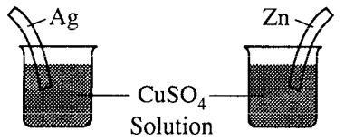
(c) What will be observed on the surfaces of zinc and silver strips shortly after they are placed in separate solutions of CuSO₄, as shown on the right? Account for these observations.
(d) A water solution of I₂ is shaken with an equal volume of a nonpolar solvent such as TTE (tri-chlorotrifluoroethane). Describe the appearance of this system after shaking. (A diagram may be helpful.) Account for this observation.
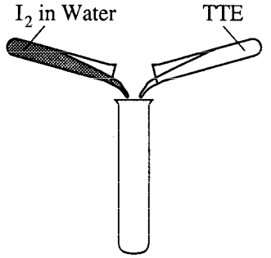
Answer:
(c) No reaction in the Ag | Cu²⁺ beaker because Ag⁺ is easier to reduce than Cu²⁺.
The zinc will go into solution as Zn²⁺ while the Cu²⁺ will reduce to Cu, forming on the surface of the zinc.
Zn(s) + Cu²⁺ → Zn²⁺ + Cu(s) E°_{cell} = + 1.10 v
(d) (i) Water and TTE will form separate layers becasue the polar water is not miscible with the non-polar TTE.
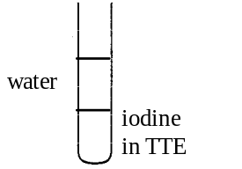
(ii) The TTE will be the bottom layer because its density is greater than the water.
(iii) The non-polar iodine will dissolve better in the non-polar TTE and form a pinkish-purple tint.

1996 D
A 0.500-gram sample of a weak, nonvolatile acid, HA, was dissolved in sufficient water to make 50.0 milliliters of solution. The solution was then titrated with a standard NaOH solution. Predict how the calculated molar mass of HA would be affected (too high, too low, or not affected) by the following laboratory procedures. Explain each of your answers.
(a) After rinsing the buret with distilled water, the buret is filled with the standard NaOH solution; the weak acid HA is titrated to its equivalence point.
(b) Extra water is added to the 0.500-gram sample of HA.
(c) An indicator that changes color at pH 5 is used to signal the equivalence point.
(d) An air bubble passes unnoticed through the tip of the buret during the titration.
Answer:
(a) too low; molarity NaOH is lower concentration (through dilution with the drops of distilled water remaining in the buret) than standard leading to a higher volume used in titration, since M_{B}V_{B} = mol_{A} and 0.500 g/mol_{A} = molar mass, then a larger denominator gives a result that is too small.
(b) not affected; extra water changes neither the moles of acid originally measured nor the volume of base required to reach the end point.
(c) too high; the equivalence point is reached with too little volume of base, since M_{B}V_{B} = mol_{A} and 0.500 g/mol_{A} = molar mass, then a smaller denominator gives a result that is too large.
(N.B., there would be no effect if the NaOH were standardized with the same indicator)
(d) too low; the volume of NaOH would be higher than expected, since M_{B}V_{B} = mol_{A} and 0.500 g/mol_{A} = molar mass, then a larger denominator gives a result that is too small.

1997 D
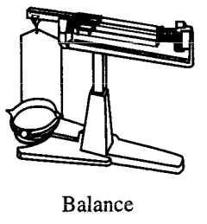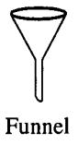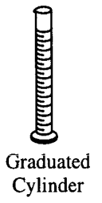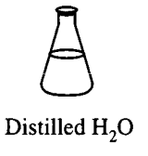
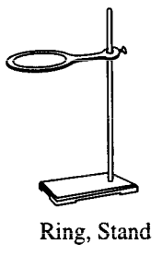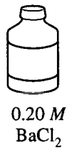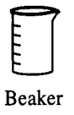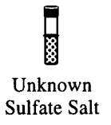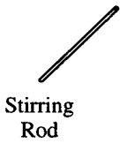
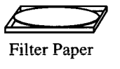
An experiment is to be performed to determine the mass percent of sulfate in an unknown soluble sulfate salt. The equipment shown above is available for the experiment. A drying oven is also available.
(a) Briefly list the steps needed to carry out this experiment.
(b) What experimental data need to be collected to calculate the mass percent of sulfate in the unknown?
(c) List the calculations necessary to determine the mass percent of sulfate in the unknown.
(d) Would 0.20-molar MgCl₂ be an acceptable substitute for the BaCl₂ solution provided for this experiment? Explain.
Answer:
(a) • mass container of unknown sulfate salt
• pour some salt into beaker
• mass container of unknown sulfate salt
• add some distilled water to dissolve salt
• add enough barium chloride solution to salt solution to precipitate all the barium sulfate
• mass filter paper
• fold filter paper, place into funnel and place into ring on stand
• filter precipitate, use distilled water to wash out beaker and pass through filter paper.
• wash ppt with distilled water
• remove filter paper and ppt from funnel and dry in oven
• mass filter paper and ppt, replace in oven and re-mass to constant weight
(b) • mass of unknown salt container before removal
• mass of unknown salt container after removal
• mass of filter paper
• mass of dried filter paper + ppt
(c) mass of unknown sulfate container, start
- mass of unknown sulfate container, end
= mass of unknown sulfate

mass of dried filter paper + ppt
- mass of filter paper
= mass of dried ppt

molar mass of BaSO₄

sulfate is 41.16% (by mass) of BaSO₄
mass of ppt × 0.4116 = mass of sulfate
f(mass of sulfate,mass of unknown sulfate) × 100 = % sulfate
(d) MgCl₂ would not be an acceptable substitute because magnesium sulfate is much more soluble than barium sulfate and would produce little or no ppt.

1998 D (Required) [repeated in acid-base section]
5. An approximately 0.1-molar solution of NaOH is to be standardized by titration. Assume that the following materials are available.
• Clean, dry 50 mL buret
• 250 mL Erlenmeyer flask
• Wash bottle filled with distilled water
• Analytical balance
• Phenolphthalein indicator solution
• Potassium hydrogen phthalate, KHP, a pure solid monoprotic acid (to be used as the primary standard)
(a) Briefly describe the steps you would take, using the materials listed above, to standardize the NaOH solution.
(b) Describe (i.e., set up) the calculations necessary to determine the concentration of the NaOH solution.
(c) After the NaOH solution has been standardized, it is used to titrate a weak monoprotic acid, HX. The equivalence point is reached when 25.0 mL of NaOH solution has been added. In the space provided at the right, sketch the titration curve, showing the pH changes that occur as the volume of NaOH solution added increases from 0 to 35.0 mL. Clearly label the equivalence point on the curve.
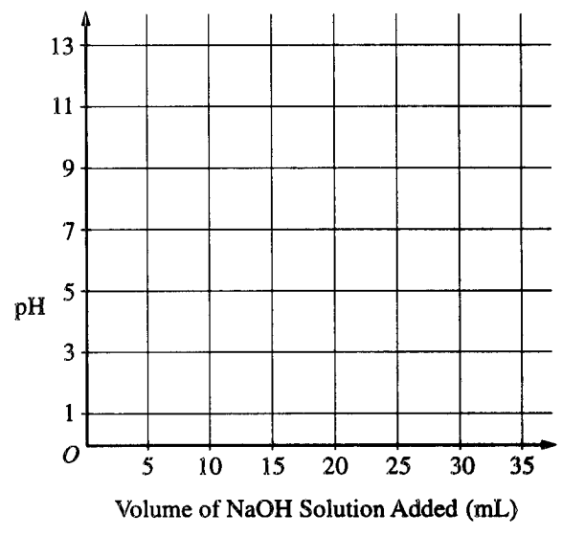
(d) Describe how the value of the acid-dissociation constant, K_{a}, for the weak acid HX could be determined from the titration curve in part (c).
(e) The graph below shows the results obtained by titrating a different weak acid, H₂Y, with the standardized NaOH solution. Identify the negative ion that is present in the highest concentration at the point in the titration represented by the letter A on the curve.
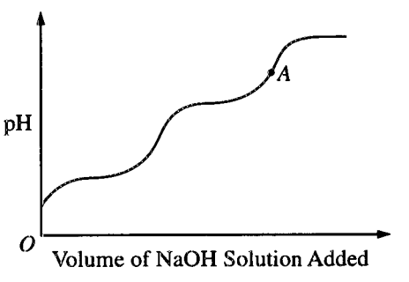
Answer
(a) • exactly mass a sample of KHP in the Erlenmeyer flask and add distilled water to dissolve the solid.
• add a few drops of phenolphthalein to the flask.
• rinse the buret with the NaOH solution and fill.
• record starting volume of base in buret.
• with mixing, titrate the KHP with the NaOH solution until it just turns slightly pink.
• record end volume of buret.
• repeat to check your results.
(b) 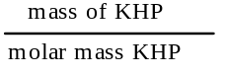 = moles of KHP
since KHP is monoprotic, this is the number of moles of NaOH
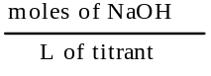 = molarity of NaOH
(c) 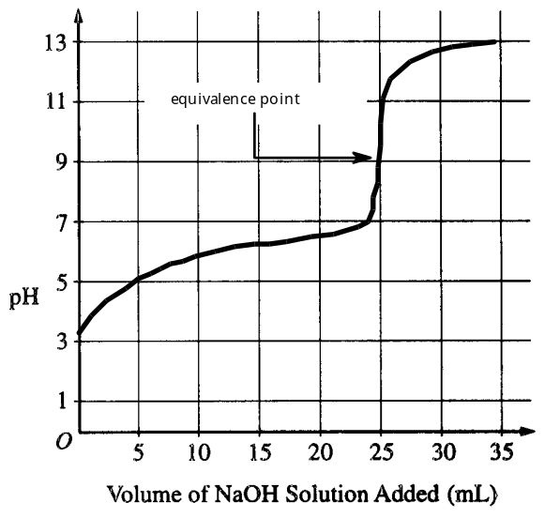
(d) from the titration curve, at the 12.5 mL volume point, the acid is half-neutralized and the pH = pK_{a}. K_{a} = 10^{pK}a
(e) Y²⁻ (could it be OH⁻ ?)

1999 D (Required)
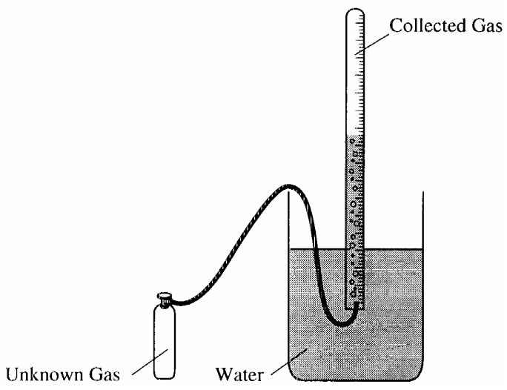
A student performs an experiment to determine the molar mass of an unknown gas. A small amount of the pure gas is released from a pressured container and collected in a graduated tube over water at room temperature, as shown in the diagram above. The collection tube containing the gas is allowed to stand for several minutes, and its depth is adjusted until the water levels inside and outside the tube are the same. Assume that:
• the gas is not appreciably soluble in water
• the gas collected in the graduated tube and the water are in thermal equilibrium
• a barometer, a thermometer, and analytical balance, and a table of the equilibrium vapor pressure of water at various temperatures are also available.
(a) Write the equation(s) needed to calculate the molar mass of the gas.
(b) List the measurements that must be made in order to calculate the molar mass of the gas.
(c) Explain the purpose of equalizing the water levels inside and outside the gas collection tube.
(d) The student determines the molar mass of the gas to be 64 g mol–1. Write the expression (set-up) for calculating the percent error in the experimental value, assuming that the unknown gas is butane (molar mass 58 g mol–1). Calculations are not required.
(e) If the student fails to use information from the table of the equilibrium vapor pressures of water in the calculation, the calculated value for the molar mass of the unknown gas will be smaller than the actual value. Explain.
Answer
(a) barometric pressure
– vapor pressure water
= pressure of dry gas
mass of gas bottle, start
– mass of gas bottle, end
= mass of gas in collection tube
mol of gas = n = ; = molar mass
(b) mass of gas bottle, start
mass of gas bottle, end
barometric pressure
volume of gas in collection tube
temperature of gas
look-up in handbook or table: equilibrium vapor pressure of water at specific temperature and ideal gas constant, R.
(c) equilizing water levels equilizes the internal collection tube pressure to the external barometric pressure.
(d) x100% = % error
(e) if the water vapor pressure is not subtracted from the total pressure, the apparent gas pressure is too large; this gives a larger value for the number of moles; in turn, since the mass of the gas is divided by too large a number of moles, the molar mass is too small.

